**Customer ID creation for JAZZ ALM**

**Note: there are ID showd in this document is not vaild, just to take screen shot, we enterd the named and password, without saving it.**

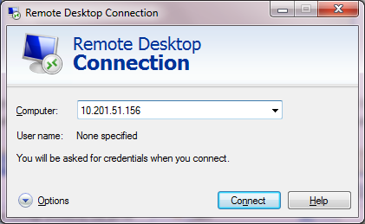

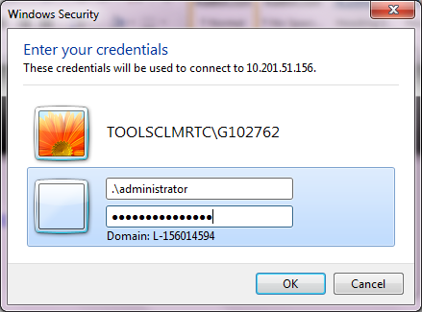

Below screen shot just shows the Host name ( for reference ) , nothing to do with this.

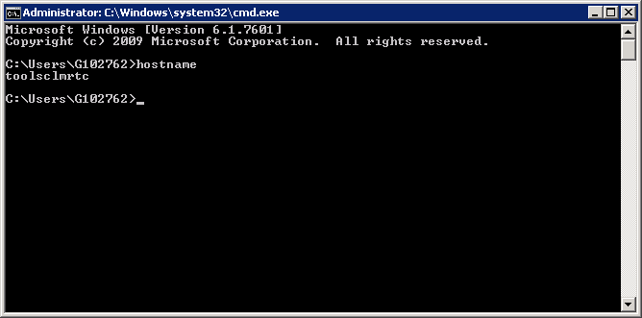

<https://localhost:9043/ibm/console/logon.jsp>

IBM Administration console-> Manage Users

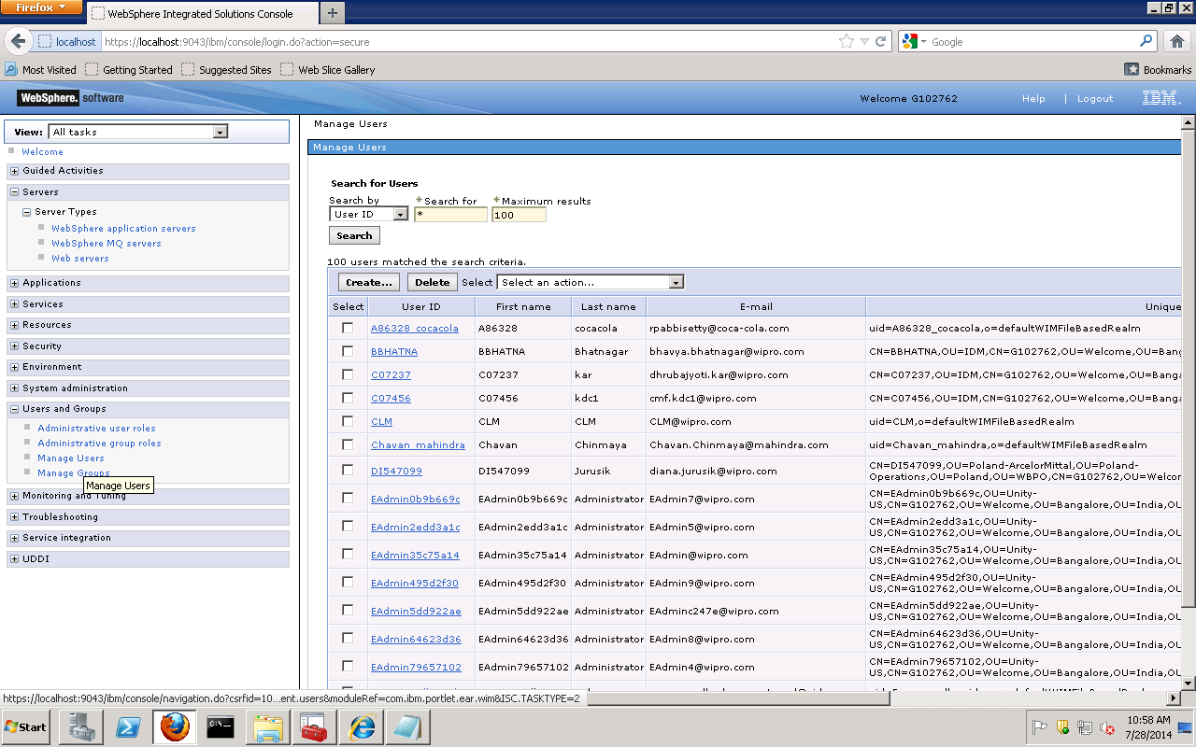

Choose Create

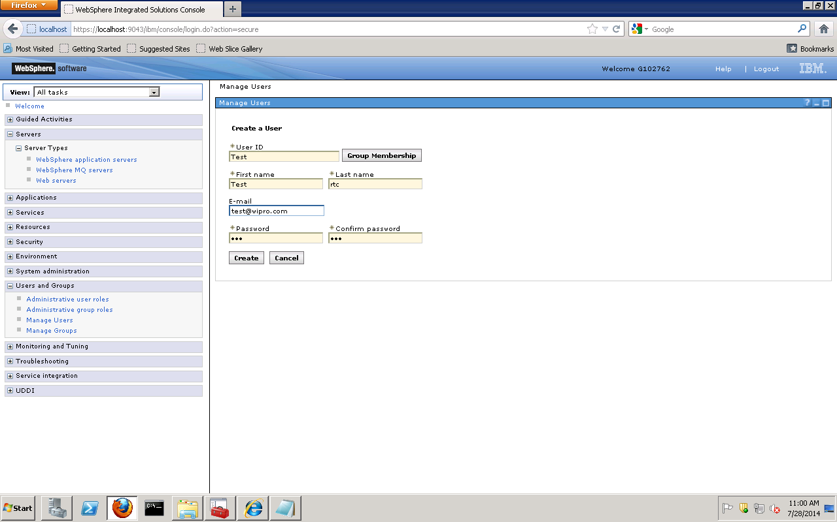

Go to groups and select [tgrtclocalusers](https://localhost:9043/ibm/console/pa.do?csrfid=1096416246&_pa=1134559554&_rid=-4b81b4b:1477b6fa2d9:66ee&.pa=true&action=props&refresh=true&id=cn%3Dtgrtclocalusers%2Co%3DdefaultWIMFileBasedRealm) >Members tab >add users

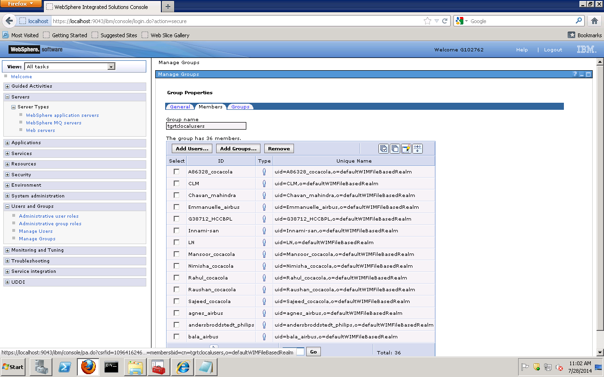

Go to elitealm jts/admin>advanced properties

<https://elitealm.companyname.com:9443/jts/admin#action=com.ibm.team.repository.admin.configureAdvanced>

Go to “com.ibm.team.repository.service.jts.internal.userregistry.ExternalUserRegistryInternalService”

And Change LDAP to UNSUPPORTED and save

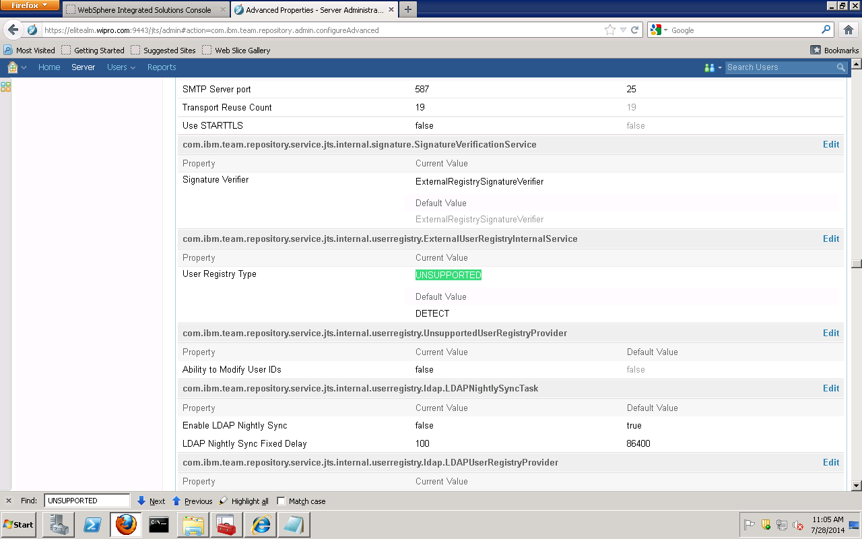

Go to Users>Create Users>Enter the same Name which created in WAS profile and assign license

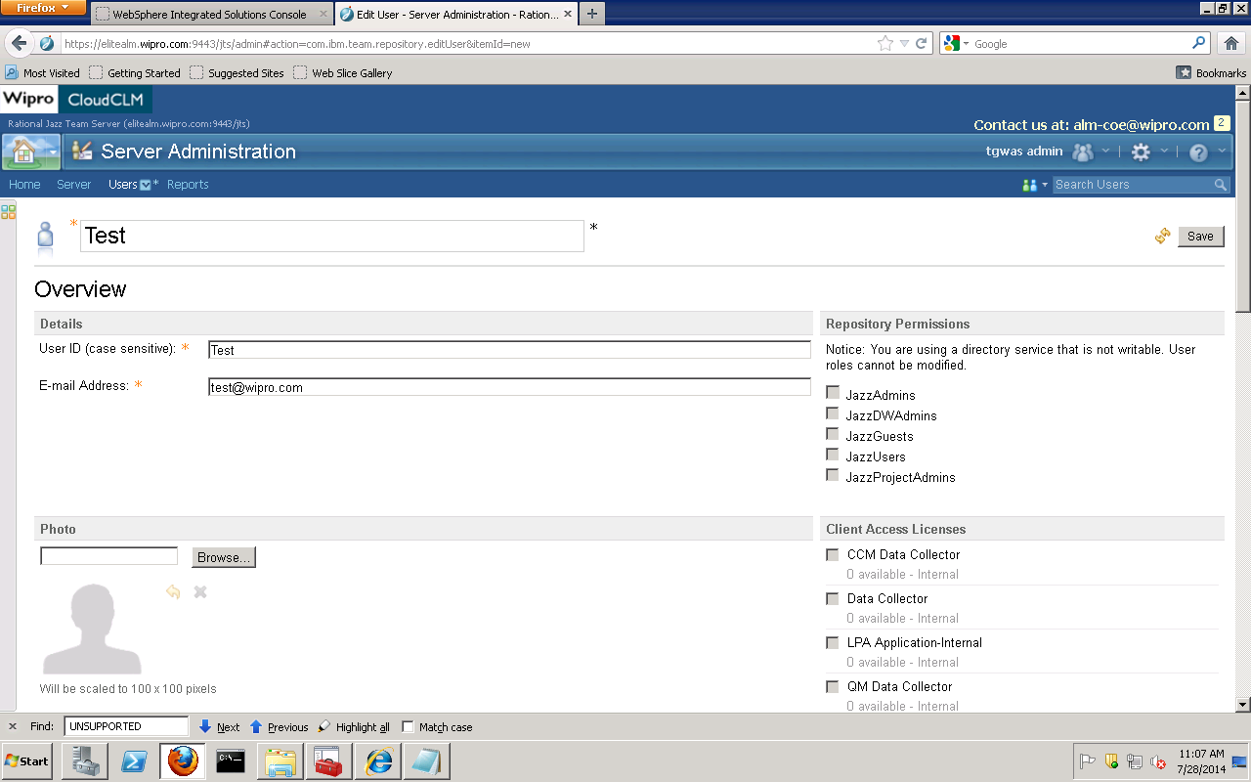

Go to elitealm jts/admin>advanced properties and Change UNSUPPORTED to LDAP and save

